|  |
| --- |
| **Kenai BEACH Water Quality Monitoring**  **and Pathogen Detection** |
| **August 2012**  **Updated March 2019**  **Updated March 2020** |
| **Quality Assurance Project Plan, Rev. 4** |
|  |
| **Alaska Department of Environmental Conservation**  **Division of Water** |

# PROJECT MANAGEMENT ELEMENTS

## Title and Approvals

Title: Kenai River Beach Tier 2 Quality Assurance Project Plan for Water Quality Monitoring Sampling and Analysis Activities

|  |  |  |  |  |
| --- | --- | --- | --- | --- |
| Bob Frates, Project Manager  Affiliation: City of Kenai Parks & Recreation | |  | Phone: (907) 283-8261  email: [bfrates@kenai.city](mailto:bfrates@kenai.city) | |
| Signature: |  |  | Date: |  |
| Margaret Harings, Project QA, Project Manager  Affiliation: Kenai Watershed Forum | |  | Phone: (907) 260-5449  email: maggie@kenaiwatershed.org | |
| Signature: |  |  | Date: |  |
| Sarah Apsens, DEC DOW Project Manager  DEC DOW WQS Program | |  | Phone: (907) 262-3411  email: [sarah.apsens@alaska.gov](mailto:sarah.apsens@alaska.gov) | |
| Signature: |  |  | Date: |  |
| John Clark, DEC DOW QA Officer DEC DOW WQSAR Program | |  | Phone: (907)269-3066  email: [john.clark @alaska.gov](mailto:John.clark%20@alaska.gov) | |
| Signature: |  |  | Date: |  |
|  | |  |  | |
|  |  |  |  |  |

**Table of Contents**

A. PROJECT MANAGEMENT ELEMENTS 2

A.1 Title and Approvals 2

A.2 DISTRIBUTION LIST 6

A.3 PROJECT TASK/ORGANIZATION 6

A.3.1 Project Grantee 6

A.3.2 DEC Staff: 7

A.4 PROBLEM DEFINITION/BACKGROUND AND PROJECT OBJECTIVES 8

A.4.1 Problem Definition 8

A.4.2 Project Background 9

A.4.3 Project Objective(s) 9

A.5 PROJECT/TASK DESCRIPTION and SCHEDULE 9

A.5.1 Project Description 9

A.5.2 Project Implementation Schedule 10

A.6 DATA QUALITY OBJECTIVES AND CRITERIA FOR MEASUREMENT DATA 10

A.6.1 Data Quality Objectives (DQOs) 10

A.6.2 Measurement Quality Objectives (MQOs) 11

A.7 SPECIAL TRAINING REQUIREMENTS/CERTIFICATION 16

A.8 DOCUMENTS AND RECORDS 17

B. DATA GENERATION AND ACQUISITION 19

B.1 SAMPLING PROCESS DESIGN (Experimental Design) 19

B.1.1 Define Monitoring Objectives(s) and Appropriate Data Quality Objectives 20

B.1.2 Characterize the General Monitoring Location/s 24

B.1.3 Identify the Site-Specific Sample Collection Location/s, Parameters to be measured and Frequencies of Collection 25

B.2 SAMPLING METHOD REQUIREMENTS 25

B.2.1 Sample Types 26

B.2.2 Sample Containers and Equipment 26

B.2.3 Sampling Methods 28

B.3 SAMPLE HANDLING AND CUSTODY REQUIREMENTS 28

B.3.1 Sampling Procedures 28

B.3.2 Sample Custody Procedures 28

B.3.3 Shipping Requirements 29

B.4 ANALYTICAL METHODS AND REQUIREMENTS 30

B.4.1 Sampling Parameters 30

B.5 QUALITY CONTROL REQUIREMENTS 32

B.5.1 Field Quality Control (QC) 32

B.5.2 Laboratory Quality Control (QC) Measures 33

B.6 INSTRUMENT/EQUIPMENT TESTING, INSPECTION AND MAINTENANCE REQUIREMENTS 34

B.7 INSTRUMENT CALIBRATION AND FREQUENCY 34

B.8 INSPECTION/ACCEPTANCE OF SUPPLIES AND CONSUMABLES 35

B.9 DATA ACQUISITION REQUIREMENTS (NON-DIRECT MEASUREMENTS) 35

B.10 DATA MANAGEMENT 35

C. ASSESSMENT AND OVERSIGHT 39

C.1 ASSESSMENTS AND RESPONSE ACTIONS 39

C.1.1 Lab Assessments to be performed under the BEACH Monitoring Program: 39

C.1.2 On-Site assessments to be performed under the BEACH Monitoring Program: 39

C.1.3 Project Data Assessments: 40

C.2 REVISIONS TO QAPP 40

C.3 QA REPORTS TO MANAGEMENT 40

D. DATA VALIDATION AND USABILITY 41

D.1 DATA REVIEW, VERIFICATIONAND VALIDATION REQUIREMENTS 41

D.1.1 Data Validation 42

D.1.2 Data Verification 42

D.1.3 Data Review 42

D.2 VERIFICATION AND VALIDATION METHODS 42

D.2.1 Validation Methods 42

D.2.2 Verification Methods 43

D.3 RECONCILIATION WITH USER REQUIREMENTS 44

E. DECISION CRITERIA 44

TABLE OF TABLES

Table 1: Distribution List 6

Table 2. Beach Names and Locations 8

Table 3: Project Implementation Schedule 10

Table 4: Project Measurement Quality Objectives (MQOs) 14

Table 5: Training 17

Table 6: Project Documents and Records 19

Table 7. Sampling Dates and Locations 22

Table 8: Site Location and Rationale 24

Table 9: Site-Specific Sample Parameters to be Measured and Collection Frequency 25

Table 10: Preservation and Holding Times for the Analysis of Samples 27

Table 11: Sample Transport Chain Information 30

Table 12: Field Quality Control Samples 33

Table 13: QA Reports to Management 40

TABLE OF FIGURES

Figure 1: BEACH Project Organizational Structure 8

Figure 2: Data Management Flow Chart 38

## DISTRIBUTION LIST

This list includes the names and addresses of those who receive copies of the approved QAPP and subsequent revisions.

|  |  |  |  |  |
| --- | --- | --- | --- | --- |
| Table 1: Distribution List | | | | |
| NAME | POSITION | AGENCY/  Company | DIVISION/BRANCH/SECTION | CONTACT INFORMATION |
| Sarah Apsens | Project Manager | DEC | Division of Water/ WQSAR | 907-262-3411  [sarah.apsens@alaska.gov](mailto:sarah.apsens@alaska.gov) |
| John Clark | QA Officer | DEC | Division of Water/ WQSAR/QA | 907-269-3066  [john.clark@alaska.gov](mailto:john.clark@alaska.gov) |
| Margaret Harings | Grantee Project Manager/Beach Water Sampler | KWF | KWF | 907-260-5449  maggie@kenaiwatershed.org |
| Margaret Harings | Grantee Project QA Officer | KWF | KWF | 907-260-5449  maggie@kenaiwatershed.org |
| Justin Nelson | Lab Manager | SGS North America Inc. | SGS North America Inc. | 907-562-2343 [justin.nelson@sgs.com](mailto:justin.nelson@sgs.com) |
| Bevin Horn | EPA Beach Grant Oversight | EPA | EPA Region 10 | 206-553-1566  [horn.bevin@epa.gov](mailto:horn.bevin@epa.gov) |
| Gretchen Augat | Alaska Beach Grant Manager | DEC | Division of Water/ WQSAR/Beach Grant | 907-465-5023  [gretchen.augat@alaska.gov](mailto:gretchen.augat@alaska.gov) |

## PROJECT TASK/ORGANIZATION

Duties and responsibilities of key individuals are listed below:

### Project Grantee

* **Lead Field Sampler/Project Manager** – Responsible for sampling preparation, sample collection, sample preservation, transportation of samples to commercial air carrier for shipping, receipt of data and transmittal of data to Project Manager. The individual will: procure personal equipment of field personnel, coordinate with laboratories in planning sampling equipment needs, obtain supplies for and prepare daily sampling kits prior to departure for field location, travel to the field location, prepare necessary preservatives while in the field, perform site reconnaissance, collect site specific parameters, collect water samples, prepare samples for shipping, transport samples to an air carrier, arrange for sample shipping, alert couriers and laboratories of successful sampling event, receive data from laboratory, validate data, input data into a specified excel spreadsheet, verify sample result data is reliable and submit the data and all applicable QA/QC results to the DEC Project Manager.
* **Project QA Officer** – Responsible to ensure all monitoring complies with the QAPP specified criteria. This is accomplished through routine technical assessments of the sample collection, analysis and data reporting process. Assessments may include, but are not limited to: on-site field audits, data audits, QA review of blind lab performance evaluation samples, lab audits, etc. These assessments are performed independent of overall project management. Because the Kenai Watershed Forum is a small organization, the Project Manager also serves as QA Officer for this project. The Project Manager will work closely with the DEC Project Manager in the design, and implementation of this project. All data submitted to DEC undergoes quality assurance by Branden Bornemann (KWF Director), the DEC Project Manager, and the DEC QA Officer.
* **Field Support Personnel**- Responsible for assisting Lead Field Sampler. The individual will travel with the Lead Field Sampler to the field location, accompany the Lead Field Sampler to sampling sites, and support Lead Field Sampler in sampling tasks.
* **Laboratory Manager** – Responsible for the overall review and approval of contracted laboratory analytical work, responding to sample result inquiries and method specific details. Responsible for QA/QC of laboratory analysis as specified in the QAPP and reviews and verifies the validity of sample data results as specified in the QAPP and appropriate EPA approved analytical methods.

### DEC Staff:

* **DEC Project Managers** – Responsible for overall technical and contractual management of the project. If DEC staff have direct responsibility for sample collection and analysis of data results, the DEC Project Manager/s assume the responsibilities of the Lead Field Sampler/Project Manager.
* **DEC Water Quality Assurance Officer (WQAO)** – Responsible for QA review and approval of plan and oversight of QA activities ensuring collected data meets project’s stated data quality goals. If DEC staff have direct responsibility for sample collection and analysis of data results, the DEC WQAO assumes the responsibilities of the Project QA Officer.

Figure 1: BEACH Project Organizational Structure

DEC DOW

Project Manager

DEC DOW

QA Officer

DEC DOW Data Base (AWQMS, DROPS)

Field Sampling

Laboratory

Sampling & Analysis Manager

Project Manager

Project QA Officer

Management Direction

Data Reporting

QA Assessment/Reporting

## PROBLEM DEFINITION/BACKGROUND AND PROJECT OBJECTIVES

### Problem Definition

DEC identified the following beaches through a public nomination process; the Recreational Beach Survey is available at: <http://www.dec.state.ak.us/water/wqsar/wqs/pdfs/Beach_Survey.pdf>. The qualifying Beaches are:

Table 2. Beach Names and Locations

|  |  |  |  |
| --- | --- | --- | --- |
| Beach Name | PRAWN ID | Latitude | Longitude |
| South Kenai Beach 3 (SKB3) | AK802097-003 | 60.54332 | -151.26532 |
| North Kenai Beach 4 (NKB4) | AK551272-004 | 60.54978 | -151.26804 |
| Kenai River Gull Rookery (KRGR1) | N/A | 60.53660 | -151.25400 |
| Kenai River Gull Rookery (KRGR2) | N/A | 60.55180 | -151.24400 |
| Warren Ames Bridge (BRG1) | AK574820-001 | 60.5259 | -151.20647 |

*PRAWN is an EPA database specific to the EPA BEACH program. Each beach has a unique PRAWN ID number.

Based on the information provided by respondents, DEC ranked these beaches as Tier 1. Tier 1 includes high priority beaches that pose the greatest threat of human contact with contaminated waters during recreational use. Contact with waters containing fecal contamination increases the risk of becoming ill due to pathogens contained in feces.

### Project Background

DEC has, and continues to implement a Beach Grant monitoring model which partners with local interested organizations and the general public to monitor levels of fecal contamination and evaluate the potential risks associated with recreational beach use. While this model is effective in providing support to communities monitoring marine water quality adjacent to high use beaches, it has not been successful in monitoring all high priority, Tier 1, beaches in Alaska on a desirable basis. Data associated with monitoring efforts at these beaches are on file and can be obtained by contacting the Project Manager.

### Project Objective(s)

The primary objective of this DEC BEACH Monitoring Program project is to sample identified beaches for fecal indicator organisms (fecal coliforms and enterococci bacteria) that signify the presence of fecal contamination. This information will be used to notify the public in the event an exceedance of allowable levels of indicator organisms in accordance to Alaska Water Quality Standards (WQS). In addition to determining bacteria exceedances, sources of fecal bacteria will be identified using Molecular Source Tracking (MST). Samples for MST will be collected before, and during the salmon dipnet fishery. Host markers will include human, gull, and dog.

The secondary objective is to obtain a set of at least five samples per beach within a 30-day period. The geometric mean of these samples will then be used when reevaluating the ranking of these beaches as Tier 1. If the geometric mean of a beach meets WQS standards, it is possible the beach will be downgraded to a lower Tier. This would reduce the number of beaches categorized as high priority and, assuming no new beaches are nominated and ranked as high priority, increase the percentage of high priority beaches that can be monitored at a desirable frequency using grantees.

## PROJECT/TASK DESCRIPTION and SCHEDULE

### Project Description

The Kenai Watershed Forum (KWF) as a contractor for the City of Kenai will collect water samples from two (2) Tier 1 beaches and one (1) reference site. Samples will be analyzed at a DEC-approved laboratory for presence of fecal coliforms by SM 9222 D, and Enterococci by ASTM D6503. MST will be used to help assess fecal bacteria sources. The goal of this project is to gather enough data to determine whether these beaches are meeting the water quality standards for fecal coliforms and enterococci based on single sample and/or geometric mean calculations. A list of DEC-approved microbiological laboratories is available at: <http://dec.alaska.gov/applications/eh/EHLabStatus/MicroReport/Index>.

### Project Implementation Schedule

|  |  |  |  |  |
| --- | --- | --- | --- | --- |
| Table 3: Project Implementation Schedule | | | | |
| **Product** | **Measurement/ Parameter(s)** | **Sampling Site** | **Sampling Frequency** | **Time Frame** |
| QAPP Preparation |  |  |  | Spring 2020 |
| Field Sampling | Ambient air temperature, HANNA handheld tester (pH, conductivity, TDS, water temperature),turbidity | All sites | On sample collection dates | May-September 2020 |
| Lab Analysis | Fecal coliforms and Enterococci | All sites | Analyses within sample holding time requirements | May- September 2020 |
| Field Audit | Audit of field monitoring operations | All sites | < 30 days of project start-up | 1/project |
| Data Analysis | All parameters | All sites |  | November 2020 |
| Data Review | All parameters | All sites |  | December 2020 |
| Data Report | All parameters | All sites |  | February 2021 |

## DATA QUALITY OBJECTIVES AND CRITERIA FOR MEASUREMENT DATA

### Data Quality Objectives (DQOs)

Data Quality Objectives (DQOs, EPAQA/G4). DQOs are qualitative and quantitative statements derived from the DQO Process that:

* Determine ambient beach water concentrations of indicator organisms (fecal coliforms and enterococci) and compare these values to water quality standards regulatory limits for fecal coliform bacteria in marine waters.
* The data needed for this project is indicator organism concentrations. The ultimate goal of the project is to intensively monitor beaches that are currently considered Tier I to determine if there truly is a problem with fecal contamination. If so, beaches may be listed as impaired waters. If not, beaches will be down-tiered to a lower priority level. In order to accomplish the monitoring objectives, the appropriate type of data needed is defined by the WQS for bacteria (fecal coliform and enterococci). For WQS pollutants, compliance with the WQS is determined by specific measurement requirements. The measurement system is designed to produce water pollutant concentration data that are of the appropriate quantity and quality to assess compliance.

### Measurement Quality Objectives (MQOs)

Measurement Quality Objectives (MQOs) are a subset of DQOs. MQOs are derived from the monitoring project’s DQOs. MQOs are designed to evaluate and control various phases (sampling, preparation, and analysis) of the measurement process to ensure that total measurement uncertainty is within the range prescribed by the project’s DQOs. MQOs define the acceptable quality (data validity) of field and laboratory data for the project. MQOs are defined in terms of the following data quality indicators:

* Detectability
* Precision
* Bias/Accuracy
* Completeness
* Representativeness
* Comparability

Detectability is the ability of the method to reliably measure a pollutant concentration above background. DEC DOW uses two components to define detectability: method detection limit (MDL) and practical quantification limit (PQL) or reporting limit (RL).

* The MDL is the minimum value which the instrument can discern above background but no certainty to the accuracy of the measured value. For field measurements the manufacturer’s listed instrument detection limit (IDL) can be used.
* The PQL or RL is the minimum value that can be reported with confidence (usually some multiple of the MDL).

Note: The measurement method of choice should at a minimum have a practical quantification limit or reporting limit 3 times more sensitive than the respective DEC WQS and/or permitted pollutant level (for permitted facilities).

Sample data measured below the MDL is reported as ND or non-detect. Sample data measured ≥ MDL but ≤ PQL or RL is reported as estimated data. Sample data measured above the PQL or RL is reported as reliable data unless otherwise qualified per the specific sample analysis.

Precision is the degree of agreement among repeated measurements of the same parameter and provides information about the consistency of methods. Precision is expressed in terms of the relative percent difference (RPD) between two measurements (A and B).

For field measurements, precision is assessed by measuring replicate (paired) samples at the same locations and as soon as possible to limit temporal variance in sample results. Field and laboratory precision is measured by collecting blind (to the laboratory) field replicate or duplicate lab samples. For paired and small data sets project precision is calculated using the following formula:

For larger sets of paired precision data sets (e.g., overall project precision) or multiple replicate precision data, the following formula may be used:

RSD = 100*(standard deviation/mean)

Note: Precision assessed only when both paired values ≥:

* 5 times PQL (fecal coliforms SM 9222D)
* 2 times PQL (enterococci D-6503-99)

Bias (Accuracy) is a measure of confidence that describes how close a measurement is to its “true” value. Methods to determine and assess accuracy of field and laboratory measurements include, instrument calibrations, various types of QC checks (e.g., sample split measurements, sample spike recoveries, matrix spike duplicates, continuing calibration verification checks, internal standards, sample blank measurements (field and lab blanks), external standards), performance audit samples (DMRQA, blind Water Supply or Water Pollution PE samples from A2LA certified, etc., Bias/Accuracy is usually assessed using the following formula:

Completeness is a measure of the percentage of valid samples collected and analyzed to yield sufficient information to make informed decisions with statistical confidence. As with representativeness, data completeness is determined during project development and specified in the QAPP. Project completeness is determined for each pollutant parameter using the following formula:

Where: T = Total number of expected sample measurements.

I = Number of invalid sample measured results.

NC = Number of sample measurements not produced (e.g., spilled sample).

This project has a goal of 80% data completeness. Completeness will be assessed on an individual basis for every beach. For comparison with the geometric mean standard, ten individual sampling events are planned and a minimum of five unique and valid samples (per sample location) are required to assess compliance with the beach monitoring water quality indicator standards.

Representativeness is determined during project development and specified in the QAPP. Representativeness assigns what parameters to sample for, where to sample, type of sample (grab, continuous, composite, etc.) and frequency of sample collection.

Comparability is a measure that shows how data can be compared to other data collected by using standardized methods of sampling and analysis.

Each sampling station is fixed and located by reference to a permanent landmark at each beach. The stations do not change throughout the sampling season, but may vary with tidal stage. Sampling is conducted in accordance with Alaska Beach Grant Program’s Standard Operating Procedures. The SOP’s are contained within the Sample Handbook available at:

<https://dec.alaska.gov/water/water-quality/beach-program/>

Standardized EPA-approved analytical procedures methods are used by state certified microbiological laboratories. Escherichia coli colony forming units are enumerated using EPA Method 9222D. Enterococci colony forming units are enumerated using Standard Test Method D6503-99.

| Table 4: Project Measurement Quality Objectives (MQOs) | | | | | | | | | |
| --- | --- | --- | --- | --- | --- | --- | --- | --- | --- |
| Group | Analyte | Method | MDL | PQL | Alaska Water Quality Standards | | | Precision (RPD) | Accuracy |
| Aquatic Life | Recreation Water | Harvest for Consumption of Raw Mollusks or Other Raw Aquatic Life |
|  | Temperature | In situ (electronic probe)  EPA 170.1 | NA | 0.1°C | May not cause the weekly average temperature to increase more than 1°C. The maximum rate of change may not exceed 0.5°C per hour. Normal daily temperature cycles may not be altered in amplitude or frequency. | NA | May not cause the weekly average temperature to increase more than 1°C. The maximum rate of change may not exceed 0.5°C per hour. Normal daily temperature cycles may not be altered in amplitude or frequency. | ±0.2°C | ±0.2°C |
|  | pH | In situ (electronic probe) EPA 150.2 |  |  | May not be less than 6.5 or greater than 8.5, and may not vary more than 0.2 pH units outside of the naturally occurring range. | May not be less than 6.0 or greater than 8.5. If the natural pH condition is outside this range, substances may not be added that cause any increase in buffering capacity of the water. | May not be less than 6.0 or greater than 8.5. |  | ±0.05 |
|  | Turbidity | EPA 180.1 ASTM D1889, SM 2130 B |  |  | May not reduce the depth of compensation point for photosynthetic activity by more than 10%. May not reduce the maximum secchi disk depth by more than 10% | May not exceed 25 nephelometric turbidity units (NTU) | May not reduce the depth of the compensation point for photosynthetic activity by more than 10%. May not reduce the maximum secchi disk depth by more than 10%. |  |  |
| Fecal Indicator Organisms | Fecal coliforms | SM 9222D, membrane filtration (MF) | 1cfu/100mL | 1cfu/100mL | NA | In a 30-day period, the geometric mean of samples may not exceed 200 fecal coliform/100 ml, and not more than 10% of the samples may exceed 400 fecal coliform/100 ml. | The geometric mean of samples may not exceed 14 fecal coliform/100 ml; and not more than 10% of the samples may exceed 31 CFU per 100 ml for a membrane filtration test. | ± 60% | NA |
| SM9221 E (2) with A-1 media, MPN, marine waters method | 2-1600 MPN/100ml | 2-1600 MPN/100ml |
| Enterococci | D6503-99 (Enterococci by Enterolert) | 10cfu/100mL | 10cfu/100mL | NA | In a 30-day period, the geometric mean of samples may not exceed 35 enterococci CFU/100 ml, and not more than 10% of the samples may exceed a STV of 130 enterococci CFU/100 ml. | NA | ± 60% | NA |
| Microbial Source Tracking | Polymerase Chain Reaction (PCR) | NA | NA | NA | No human or human related sources | NA | NA | NA |

## SPECIAL TRAINING REQUIREMENTS/CERTIFICATION

The DEC Project Manager currently has experience in administrating BEACH Grant Monitoring Program grants. The experience associated with their duties allows them to be effective in carrying out duties as Project Manager.

For BEACH monitoring projects awarded to grantees, the grantee is responsible to provide a knowledgeable and competent grant manager and project QA Officer.

Margaret Harings has been given beach sampling training by Branden Bornemann, who has managed the Kenai River Beach monitoring project in past years.

For BEACH monitoring projects conducted by DEC staff, the Project QA Officer is the DEC DOW’s Quality Assurance Officer. His training and experience allow him to successfully fulfill his duties as Project QA Officer.

**Project Manager/Grantee**:

Sub-contracted laboratories performing analytical work must have the requisite knowledge and skills in execution of the analytical methods being requested. Information on laboratory staff competence is usually provided in each lab’s Quality Management (QMP) and/or Quality Assurance Plan (QAP). The laboratory to be used during this field season, SGS North America Inc. meets ADEC and EPA Safe Drinking Water compliance standards. . It is the responsibility of the contracted lab to maintain a current copy of the laboratory’s QA Plan and attendant method specific SOPs on file with the Project Manager/ QA Project Manager and DEC DOW QA Officer during the duration of laboratory use.

**Lead Field Sampler/Grantee**: Margaret Harings (KWF)

**DEC Project Manager:** Sarah Apsens

**DEC QA Manager:** John Clark

**KWF Field Staff**: TBA

| Table 5: Training | | | | | |
| --- | --- | --- | --- | --- | --- |
| Specialized Training/Certification | Field Staff | Project Manager | Lab Staff | Lab Supervisor | Project QA Officer |
| Safety training | **X** | **X** | **X** | **X** | **X** |
| Water sampling techniques | **X** | **X** |  |  | **X** |
| Instrument calibration and QC activities for field measurements | **X** | **X** |  |  | **X** |
| Instrument calibration and QC activities for laboratory measurements |  |  | **X** | **X** | **X** |
| QA principles |  |  |  | **X** | **X** |
| Chain of Custody procedures for samples and data | **X** | **X** | **X** | **X** | **X** |
| Specific EPA Approved Field Measurement Method Training | **X** | **X** |  |  | **X** |
| DEC Microbiological Drinking Water Certification | Certification for microbiological analysis is limited to the individually certified analyst. | | | | |
| Specific EPA Approved Lab Analytical Method Training |  |  | **X** | **X** | **X** |

## DOCUMENTS AND RECORDS

The field logbook will be a 3-ring binder containing individual field and sanitary survey forms. Please see the Appendix for an example of these documents. The lead field sampler is responsible for ensuring that the field logbook and all field data forms are correct.

All field activities and observations will be noted in a field logbook during fieldwork. The descriptions will be clearly written with enough detail so that participants can reconstruct events later if necessary. Field logbooks will describe any changes that occur at the site, in particular, personnel and responsibilities or deviations from the QAPP/SAP as well as the reasons for the changes. Requirements for logbook entries will include the following:

* Pages will be numbered at the outset of the sampling season.
* Removal of any pages, even if illegible, will be prohibited.
* Entries will be made legibly with black (or dark) waterproof ink.
* Unbiased, accurate language will be used.
* Entries will be made while activities are in progress or as soon afterward as possible (the date and time that the notation is made should be noted, as well as the time of the observation itself). Each consecutive day's first entry will be made on a new, blank page.
* The date and time, will appear on each page.
* When field activity is complete, the logbook will be entered into the project file.

In addition to the preceding requirements, the person recording the information must initial and date each page of the field logbook. If more than one individual makes entries on the same page, each recorder must initial and date each entry. The bottom of the page must be signed and dated by the individual who makes the last entry. The field team and task leader, after reading the day’s entries, also must sign and date the last page of each daily entry in the field logbook. Logbook corrections will be made by drawing a single line through the original entry allowing the original entry to be read. The corrected entry will be written alongside the original. Corrections will be initialed and dated and may require a footnote for explanation. The type of information that may be included in the field logbook and/or field data forms includes the following:

* Names of all field staff
* A record of site health and safety meetings, updates, and related monitoring
* Station name and location
* Date and collection time of each sample
* Observations made during sample collection, including weather conditions, environmental conditions, complications, and other details associated with the sampling effort
* Sample description
* Any deviation from the sampling plan.

Field log books and sample chain-of-custody forms will be completed for all samples and kept in the project file. Laboratory data results from the laboratories are recorded on laboratory data sheets, bench sheets and/or in laboratory logbooks for each sampling event. These records as well as control charts, logbook records of equipment maintenance records, calibration and quality control checks, such as preparation and use of standard solutions, inventory of supplies and consumables, check in of equipment, equipment parts and chemicals are kept on file at the laboratory.

Any procedural or equipment problems are recorded in the field notebooks. Any deviation from this Quality Assurance Project Plan will also be noted in the field notebooks. Data results will include information on field and/or laboratory QA/QC problems and corrective actions.

In addition to any written report, data collected for the project will be provided electronically in a AQWMS/STORET compatible format, as detailed in the following web address:

<https://dec.alaska.gov/water/water-quality/ambient-water-quality-data>

All records will be retained according to state records retention schedule.

|  |  |  |  |
| --- | --- | --- | --- |
| Table 6: Project Documents and Records | | | |
| **Categories** | **Record/Document Types** | **Location** | **Retention Time** |
| Site Information | Site maps | With Grantee | Five Years |
| Site pictures | With Grantee | Five Years |
| Environmental Data Operations | QA Project Plan | Grantee and DEC | Five Years |
| Field Method SOPs | With Grantee | Five Years |
| Field Notebooks | With Grantee | Five Years |
| Sample collection/measurement records | Grantee and DEC | Five Years |
| Sample Handling & Custody Records | Grantee and DEC | Five Years |
| Inspection/Maintenance Records | Grantee and DEC | Five Years |
| Raw Data | Lab data (sample, QC and calibration) including data entry forms | Grantee and DEC | Five Years |
| Sanitary Survey Forms | Grantee and DEC | Five Years |
| Data Reporting | Progress reports | Grantee and DEC | Five Years |
| Project data/summary reports | Grantee and DEC | Five Years |
| Lab analysis reports | Grantee and DEC | Five Years |
| Data Management | Data quality assessments | Grantee and DEC | Five Years |
| Site audits | Grantee and DEC | Five Years |
| Lab audits | DEC | Five Years |
| QA reports/corrective action reports | Grantee and DEC | Five Years |
| Corrective Action Response | Grantee and DEC | Five Years |

*In addition to any written report, data collected for a project will be submitted electronically to DEC via a CD ROM or email ZIP file. All dates are to be formatted as “****MM-DD-YYYY****”.*

# DATA GENERATION AND ACQUISITION

## SAMPLING PROCESS DESIGN (Experimental Design)

Beach water quality monitoring will be conducted at Tier I beaches designated by DEC, and sample locations should be chosen to represent the most likely pathogen exposure scenario for recreational beach users. Water samples will be analyzed to determine the population densities of microbes that indicate the presence of fecal contamination; microbes to be enumerated will be enterococci and fecal coliforms, with the results reported per 100 mL marine water.

Samples will be collected in accordance with the sampling SOP (Appendix A) at locations where primary contact recreation is likely to affect beach users. Sample collection information specific to this project is included in the Appendix B.

The sample will be collected in nearshore water 3 feet deep, approximately one foot below the water surface. Replicate samples will be collected on a minimum of 20 percent of the total number of samples evenly collected over the course of the sampling season. One field blank will be analyzed for every cooler shipment produced during a sampling event for routine monitoring. The field blank will consist of sterile water provided by the analytical laboratory, which will be aseptically transferred from its sterile container into a sterile sample bottle by the sampling technician in the field. The purpose of the field blank is to check that the sampling technician is able to collect a sample without introducing indicator bacteria into the sample, and to demonstrate that the laboratory is providing sterile sample containers for the field samples.

Enterococcus and fecal coliform population densities will be determined using the EPA or DEC approved protocols yielding the most rapid results. Those protocols were selected so decisions regarding issuance of beach advisories may be made without undue delay, minimizing the potential for public health risks associated with ongoing pathogen exposure. MST will be used to help assess the source of bacteriodetes. Sample collection for MST will occur before, and during the fishery.

### Define Monitoring Objectives(s) and Appropriate Data Quality Objectives

Data from this monitoring effort will be used to determine if bacteria levels are within water quality standards in the lower Kenai River during summer (May-September). The fecal coliform most probable number (MPN) method for marine waters will be used to determine if the harvesting of raw seafood standard is being met. Samples will be collected from four (4) locations; on the North Beach, on the South Beach, at the gull rookery area, and at the Warren Ames Bridge (RM 5). The two (2) beach sites are near the mouth of the Kenai River and at the lower end of the dipnet fishery. The site at the Warren Ames Bridge is at the upper end of the dipnet fishery. The gull rookery site is in between these two locations.

**OBJECTIVE 1:** Performance monitoring of bacteria levels at Kenai River beaches post-BMP implementation

**TASK 1:** Conduct weekly from May through September 2020

**Start and end date:** May 2020 – September 2020

**Description:** The grantee, the City of Kenai (COK) will contract with the Kenai Watershed Forum (KWF) to conduct sampling. The sampling will include 14 sampling events; from the week of May 25 through the week of September 3 at the same 2019 monitoring locations using the final 2019 Kenai Beach Sampling Plan and QAPP and Beach Monitoring Handbook. DEC will provide copies of the updated BEACH Monitoring Handbook, and QAPP/SAP. KWF will review these documents to assure they will comply with the guidance the documents provide. KWF will then submit signed. QAPP/SAP to DEC for agency approval. (These documents will be reviewed and completed by DEC staff and made available to KWF).

Six samples will be collected weekly during the weeks of May 25 through June 30 on a Monday, Tuesday or Wednesday. Eight samples will be collected weekly during the weeks of July 1 through September 3 on a Monday, Tuesday or Wednesday the dipnet fishery typically runs from July 10 through July 31. Dipnetting is allowed from 6 am to 11 pm unless changed by a Fish & Game emergency order.

The marine water samples will be analyzed for fecal coliform bacteria (SM 9222D) and enterococci (ASTM D6503-99). One replicate sample for each analytical test per sampling event will be collected for quality assurance. Sample events will occur weekly, Monday through Wednesday, so that results can be reported by the following weekend.

KWF field technicians will record observations listed in EPA’s Marine Beach Sanitary Survey, such as wildlife presence, water clarity, and water and air temperature. Field technicians will use portable water quality meters to record pH, conductivity, total dissolved solids, and water temperature. A water sample will be collected for turbidity at each site. A wave stick will be used to measure wave height. All resulting data and corresponding time of collection will be recorded on field sheets.

Microbial source tracking (MST) tests to help determine fecal bacteria sources will be performed, once before the fishery, and once during the most active recreational use periods. MST hosts will include human, gull and dog markers to further assess the bacteria sources at the Kenai beaches. The MST samples will be collected and shipped immediately to SGS where they will be filtered, frozen and stored. To capture a period of elevated fecal bacteria so that the host markers will be the most defined, the fecal coliform bacteria and enterococci results reported by the DEC-approved project laboratory will be assessed and if elevated, DEC will request MST tests to be conducted on those samples. If the bacteria results are not elevated, then the process of collecting, shipping, and filter/freezing MST samples will be repeated. If the bacteria levels are elevated, SGS will overnight the samples to Source Molecular Lab in Miami, FL for analysis. The MST sample selection goal is to select elevated bacteria samples to obtain the most robust host marker.

|  |  |
| --- | --- |
| **Table 7. Sampling Dates and Locations** | |
| Month/ week of proposed sampling event | Location(s) to be sampled |
| May 25th – September 3rd, 2020 | Fecal coliform, enterococci: North Kenai Beach-4 (NKB4), South Kenai Beach-3 (SKB3), above the Kenai River Gull Rookery (KRGR1), below the Kenai River Gull Rookery (KRGR2), the Ames Bridge (BRG1) and a Quality Control (QC) sample |
| Once before and once during/after PUF | MST at all sites: North Kenai Beach-4 (NKB4), South Kenai Beach-3 (SKB3), KRGR1, KRGR2, BRG1, and a QC sample |

Field parameters will include visual observations listed in EPA’s *Marine Beach Sanitary Survey*, such as water clarity, wildlife present, human activity, and water and air temperature.

KWF will conduct the sampling events and ensure that proper sampling techniques are followed, chain-of-custody is correct, and samples are received and analyzed by the laboratory to meet the analytical holding time requirements. Samples will be shipped to the DEC-certified laboratory SGS North American Inc. in Anchorage Alaska to meet the eight hour holding time for analysis (maximum field handling time of six hours and two hours for lab analysis).

In the event of an exceedance, KWF will work with the City of Kenai and the DEC to determine how best to implement the Public Notification and Risk Communication Plan and inform the public of the exceedance.

The initial analytical data results, sanitary surveys, copies of the chain-of-custody forms, site photos and field data sheets will be provided to the DEC Project Manager within 36 hours of sampling. Final analytical data will be provided to the DEC Project Manager within ten (10) days of the sampling event. The data will be reviewed, compiled, and entered by the KWF staff using the DEC-provided template.

Samples will be collected once a week, during mid-May and early-September. The total number of sampling events would not change. The dipnet fishery typically runs from July 10 through July 31. Dipnetting is allowed from 6 am to 11 pm unless changed by a Fish & Game emergency order.

**TASK 2:** Bacterial laboratory will analyze marine water samples for fecal coliform bacterial and enterococci

**Start and end date:** May 2020 – September 2020

**Description:** The DEC-approved project laboratory will analyze marine water samples collected by KWF from the 5 monitoring sites for fecal coliform bacteria (SM 9222D) and enterococci (ASTM D6503-99). One (1) replicate sample for each analytical test per sampling event will be analyzed for quality assurance. A total of 168 samples will be analyzed for fecal coliform bacteria and enterococci from mid-May through mid-September 2020. Sample collection will occur early in the week (Monday and Tuesday; Wednesday if necessary) to allow time for the results to be communicated to the community before weekend activities.

**TASK 3:** Microbial source tracking (MST) laboratory will analyze marine water samples for human, gull and dog bacteriodetes.

**Start and end date:** July 1st – August 3rd, 2020.

**Description:** Source Molecular Corp laboratory will analyze one monitoring event for MST testing from the 5 marine water samples collected by KWF before, during (or after) the most active recreational use periods. MST hosts will include absence/presence and quantification of human, dog and gull bacteriodetes. The MST samples will be collected and shipped immediately to SGS Anchorage where they will be filtered, frozen and stored. To capture a period of elevated fecal bacteria so that the host markers will be the most defined, the fecal coliform bacteria and enterococci results reported by the DEC-approved project laboratory will be assessed and if elevated, DEC will request MST tests to be conducted on those samples. If the bacteria results are not elevated, then the process of collecting, shipping, and filter/freezing MST samples will be repeated. If the bacteria levels are elevated, SGS Anchorage will overnight the samples to Source Molecular Lab in Miami, FL for analysis. A total of 5 samples will be analyzed for absence/presence and quantification of human, dog and gull bacteriodetes.

**TASK 4:** Compile and enter project data into DEC-data template, and update GIS geodatabase and map.

**Start and end date:** May 1, 2020 – November 1st, 2020.

**Description:** KWF will compile and enter the project data into DEC-supplied data template which the DEC project manager will transfer to the DEC water quality database (AWQMS). Data will include GIS locations of sample sites in NAD83/Alaska Albers.

**TASK 5:** Prepare and submit a project report.

**Start and end date:** May 1, 2020 –February 28, 2021.

**Description:** KWF will evaluate all sample results, and submit a draft and final report of findings and conclusions. Report design should follow 2018 and 2019 Kenai Beach Monitoring reports (http://dec.alaska.gov/water/water-quality/beach-program/).

The report will include background information, the project need, objectives, and approach taken to meet the project objectives. The report will evaluate and describe project accomplishments, the environmental benefit, and suggest future actions. Water quality analysis will use the DEC’s updated Listing Methodology for Determining Water Quality Impairments from Pathogens guidance, to compare results to the Marine Water Quality Indicator Criteria for bacteria. The report will include narrative description and tabular/graphical formats to evaluate the monitoring results. The report will include a quality assurance review describing the integrity of the reported analytical results as presented in the QAPP and data quality objectives. Appendices will incorporate all project data, and appropriate references.

### Characterize the General Monitoring Location/s

In 2002 and 2003, an Alaska Beach Survey was conducted to collect information about recreational-use beaches in the state. The survey was designed to obtain information regarding the locations of recreational-use beaches, the types of recreational activities that occur there, and the levels and seasons of beach use. In addition, information regarding the types of pollution sources near these recreation areas was collected. The collected information was entered into a database and was used to rank beaches according to their relative potential pathogen-exposure risk to beach users. The results of this survey were used to create the Alaska Beach Database, which is updated as additional surveys are received.

The beaches in this study were nominated through the Alaska Beach Survey and ranked as Tier 1 High Priority beaches.

|  |  |  |  |
| --- | --- | --- | --- |
| Table 8: Site Location and Rationale | | | |
| **Site ID** | **Latitude** | **Longitude** | **Site Description and Rationale** |
| SKB3 | 60.54332 | -151.26532 | South Kenai Beach |
| NKB4 | 60.54978 | -151.26804 | North Kenai Beach |
| KRGR1 | 60.53660 | -151.25400 | Above gull rookery |
| KRGR2 | 60.55180 | -151.24400 | Below gull rookery |
| BRG1 | 60.5259 | -151.20647 | Warren Ames Bridge |
| **Note**: GIS Maps of sampling locations (large scale as well as site specific) are located in Appendix C. | | | |

### Identify the Site-Specific Sample Collection Location/s, Parameters to be measured and Frequencies of Collection

North and South Kenai beach sampling sites occur at the point of greatest ease of public access. It is assumed that the greatest use will occur at the point of greatest ease of public access. The Warren Ames Bridge and gull rookery sites were selected to provide background levels, and therefore do not necessarily occur in areas frequented by the public.

The following table details parameters to be taken at each site, the sampling frequency, and the sampling dates.

|  |  |  |  |
| --- | --- | --- | --- |
| Table 9: Site-Specific Sample Parameters to be Measured and Collection Frequency | | | |
| Measurement/ Parameter(s) | Sampling Site | Sampling Frequency | Sampling Dates |
| Grab: Fecal Coliforms, Enterococci, MST. In situ ambient air temperature, wildlife count, water temperature, pH, TDS, conductivity, turbidity. | South Kenai Beach | Weekly | May - September |
| Grab: Fecal Coliforms, Enterococci, MST. In situ ambient air temperature, wildlife count, water temperature, pH, TDS, conductivity, turbidity. | North Kenai Beach | Weekly | May - September |
| Grab: Fecal Coliforms, Enterococci, MST. In situ ambient air temperature, wildlife count, water temperature, pH, TDS, conductivity, turbidity. | Gull Rookery (site 1 and 2) | Weekly | May - September |
| Grab: Fecal Coliforms, Enterococci, MST. In situ ambient air temperature, wildlife count, water temperature, pH, TDS, conductivity, turbidity. | Warren Ames Bridge | Weekly | May - September |

## SAMPLING METHOD REQUIREMENTS

Specific sampling methods are detailed in the Sampling SOP, included in the Appendix of this QAPP.

### Sample Types

Water samples collected for bacteria will be listed as “grab” on the Chain-of- Custody and in field data sheets.

In-situ samples include: water and air temperature, pH, conductivity, total dissolved solids, and turbidity. These samples will be measured in the field with the necessary equipment (handheld probe, turbidimeter). Results will be recorded on field data sheets (see Appendix).

### Sample Containers and Equipment

The following general guidelines are listed to provide consistency among the grab samples collected from Alaskan beaches:

* Collect one sample for each recreational-use area. A sample will consist of two sample containers filled with water from one location. One of the containers will be analyzed to determine fecal coliform population densities, and the other will be analyzed for enterococcus populations.
* Wear chest-waders and elbow-length gloves during sampling.
* Collect samples in areas of greatest use by recreational users, where water is about 3 feet deep, at about knee-depth or one foot below the surface.
* Collect a field replicate sample at least 20 percent throughout the season with a minimum of one replicate per sampling day. A field replicate consists of two additional sample containers filled with water at the same location where the primary water sample set was collected.
* Use a temperature blank for each cooler.
* All sample bottles will be provided by the analytical laboratory (pre-cleaned and sterilized), and will not require rinsing with sample.
* Remove the sample container cap carefully, avoid touching the inside of the cap or the lip of the sampling container, and face into the waves or the current to avoid sample container contamination.
* Minimize sediment or debris in the sample; this may require waiting for sediment to settle after wading out to the sample collection location. If sediment or debris are present throughout the sample area, note this fact on the Beach Sampling Data Sheet.
* Grasping the open sampling container at the bottom with one hand, plunge the bottle mouth downward into the water to avoid introducing any surface scum. Position the mouth of the bottle into the current while standing downstream of the sample bottle. Tip the bottle upward to allow air to exit and the bottle to fill, and remove the bottle from the water. Pour out a small portion of the sample from the bottle to allow an airspace of about 1 inch for proper mixing before analysis. Replace the cap on the bottle and assure it is tightly closed. Label the sample bottle with sample identifier, date, and time.
* List samples as “grab” on the laboratory’s chain of custody (COC) form. Note on the COC form that the laboratory needs to send the bacterial data to three recipients: to the local beach monitor, to the BPM, and to the QAO.
* Place samples into a cooler containing frozen blue ice to maintain a chilled temperature below 10° C. The cooler should be pre-chilled before sampling begins to ensure that samples are kept cold from the time of sampling until they are analyzed. A temperature blank must be included in each cooler.
* Measure and record water temperature to 0.1°C at the time of sample collection. A note of the temperature of the cooler contents will be made upon arrival at the laboratory. The laboratory arrival temperature shall be noted on the Chain of Custody and provided to DEC in the AWQMS data template.

The sample container, preservation, and holding time requirements are tabulated below:

|  |  |  |  |  |  |
| --- | --- | --- | --- | --- | --- |
| Table 10: Preservation and Holding Times for the Analysis of Samples | | | | | |
| **Analyte** | **Matrix** | **Container** | **Necessary Volume** | **Preservation and Filtration** | **Maximum Holding Time** |
| Temperature | Surface Water | N/A, direct measurement | N/A, Direct Measurement | N/A, direct measurement | N/A, direct measurement |
| Fecal Coliform | Surface Water | G, PA | 150 mL | Cool <10oC; do not freeze,  0.0008% Na2S2O3 | 8 hours |
| Enterococci | Surface Water | Enterolert Bottle (IDEXX) | 150 mL | Cool <10oC; do not freeze,  0.0008% Na2S2O3 | 8 hours |
| Microbial Source Tracking | Surface Water | PA | 250 ml | Freeze sample filter | 24-48 hrs pre-filter, 28 days max hold time for filtered and frozen sample |
| Notes:  G = glass,  PA = autoclavable plastic | | | | | |

### Sampling Methods

Sampling Standard Operating Procedures (SSOP) are located within the Sample Handbook available at: <https://dec.alaska.gov/water/water-quality/beach-program/> (see documents). A copy of the SSOP is located in the appendix.

Beach Grab Samples – Sample bottles will be filled sequentially, normally being filled to the shoulder of the bottle, leaving a small space for expansion and mixing. The laboratory will provide sampling instructions with the sample bottles.

***In-situ Samples*** – Conductivity, pH, total dissolved solids, and water temperature will be measured using a handheld probe. Place the measurement end of the probe upstream of sampler, in undisturbed water, and stir gently until the measurement has stabilized. Record measurement. For turbidity fill the provided glass vial with water (invert glass, submerge ~0.5m below water surface, and revert to fill). Place vial in the provided turbidimeter, hit the analysis button, record measurement. For detailed instructions on calibration, use, and maintenance of in-situ collection devices see the Kenai Beach Monitoring Handbook.

## SAMPLE HANDLING AND CUSTODY REQUIREMENTS

### Sampling Procedures

See Section B.2 of this QAPP – Sampling Method Requirements SOP.

### Sample Custody Procedures

Samples and sample containers will be maintained in a secure environment from the time the bottles leave the laboratory until the samples are received at the laboratory. The laboratories will maintain custody of bottles and samples using their normal custody procedures.

Samples must be in the sampler’s possession or in a cooler sealed with signed and dated friable evidence tape on opposing sides of the cooler. When the cooler is sealed, the method of securing the samples must be such that tampering with samples or bottles is not possible. The cooler must be secured so that the lid cannot be removed without breaking the evidence tape or cutting the lock.

Transfer of samples will be accomplished using the laboratory’s Chain-of-Custody (COC) form. When samples are transferred between personnel, such transfer will be indicated on the COC form with signature, date, and time of transfer. The COC will remain with the samples, sealed inside the cooler, until received by the laboratory. A copy of the laboratory COC form is attached as Appendix D.

If custody is broken at any time during sample transfer, a note must be made on the COC form accompanying the sample. Upon receipt at the laboratory, the laboratory sample custodian will make note if a breach of custody has occurred (for example, if a custody seal has broken during transport).

### Shipping Requirements

Packaging, marking, labeling, and shipping of samples will comply with all regulations promulgated by the U. S. Department of Transportation in 49 CFR 171-177. Staff should receive the necessary training for shipping samples or consult with the contracted laboratory for shipping instructions.

Samples will be individually packaged in sealed plastic bags. The sealed plastic bags will be placed into a bag-lined cooler with ice sealed in plastic bags or “blue-ice” to maintain a temperature of less than four degrees C. A temperature blank, 250 or 500 mL in size, will be placed in the cooler. Temperature will be measured prior to shipment and upon receipt at the lab. The chain of custody (COC) form will be placed in a plastic bag within the cooler. The cooler will be taped closed securely using packing tape at the last sampling site.

The eight (8) hour holding time limitation for the samples must be met. To accomplish this, this project will use a combination of transportation to get the samples from beach to laboratory and samples prepared and incubation initiated within the specified hold time. For those projects without laboratories in their communities, samples will be packaged at the sampling site, driven by car to the nearest airport, picked up by a courier, and then delivered to the laboratory. Other projects will deliver samples directly to the contracted laboratory.

| Table 11: Sample Transport Chain Information | | | | | | |
| --- | --- | --- | --- | --- | --- | --- |
| Business Type | Name | Address | Hours | Contact Information | Transport Leg | Estimated Transit Time |
| Air Carrier | Ravn Aviation | Kenai | 08:30-20:30 | 907-243-2761 | Kenai to Anchorage | 40 min |
| Air Carrier | Grant Aviation | Kenai | 06:30 – 22:50 (M-F), *No  flights S-Su | 907-290-3383 | Kenai to Anchorage | 40 min |
| Courier | Fed Ex Ship Center | Anchorage | 08:00-19:00 (M-Th), 10:00-15:00 (F), *Closed Su. Latest express drop off 14:30 (M-F) | 800-463-3339 | Anchorage to Miami (Shipping handled by SGS) | 24 hrs |
| Courier | UPS Cargo Next Day Air | Anchorage | Schedule packaged drop off by 12:00, deliver by 13:00 for next day delivery at 09:00 | 1-866-742-5877 | Anchorage to Miami (Shipping handled by SGS) | 24 hrs |

## ANALYTICAL METHODS AND REQUIREMENTS

Water quality analytical methods that will be used throughout this project are outlined below. All analysis methods used for this program are EPA-Clean Water Act (CWA) approved. The contracted laboratory will be a currently DEC Drinking Water -certified laboratory, though the lab will be using methods specified for water/wastewater analysis. The contracted laboratory’s current Quality Assurance Plan will be on file with DEC Division of Water Quality Assurance Office detailing their quality assurance procedures. Laboratory turnaround time is 20 business days. Any issues regarding analytical data quality will be resolved by the DEC project manager in consultation with any or all of the following: DEC QA Officer, grantee, sampling staff and the laboratory project manager.

### Sampling Parameters

Temperature will be reported in °C, and will be measured using a HANNA handheld meter (model number HI98129) or an equivalent meter (minimum resolution of 0.1 degree C or better). The thermometer will have current NIST traceable certification over the expected range of sample measurements.

pH, TDS, Conductivity will be collected using a HANNA HI98129 handheld meter or similar device. Equipment must be calibrated prior to sampling season. See the appendices in the Kenai Beach Monitoring Handbook for calibration information.

Turbidity will be measured using a HACH 2100Q IS Portable Turbidimeter (or similar device approved by DEC). Fill provided sample vial following the manufactures instructions. Device must be calibrated prior to sampling event. See the appendices in the Kenai Beach Monitoring Handbook for calibration information.

Other environmental parameters include wave height, water clarity, wind direction and speed, number of birds present. Wave height will be measured using a meter stick or similar device. Stick will be placed vertically in the water column at the sample site. Sampler will note the maximum wave height observed.

Fecal Coliform Standard Method 9222D will be used to determine the fecal coliform concentration in surface water. Filter sample through a membrane filter. Place membrane on mFC agar containing aniline blue as indicator. Incubate at 44.5°C for 22-24 h. Colonies that are various shades of blue are positive for fecal coliforms. The blue color indicates the capability to ferment lactose to acid.

Enterococci ASTM Method D6503-99 will be used to determine the most probable number enterococci concentration in surface water. Add reagent to the sample, pour into Quanti-Tray® or Quanti-Tray® /2000, seal in Quanti-Tray® Sealer and incubated for 24 hours at 41°C. Count fluorescent wells and refer to most probable number table.

Monitoring shall be conducted in accordance with EPA-approved analytical procedures and in compliance with 40 CFR Part 136, Guidelines Establishing Test Procedures for Analysis of Pollutants. Reference the Project’s MQO Table 3(section A.6.2) of this QAPP for list of parameters of concern, approved analytical methods, method-specific detection and reporting limits, accuracy and precision values applicable to this project. 40 CFR, Part 136.6 lists other regulated pollutant parameters not listed in the MQO Table 3(section A.6.2).

An expedited reporting turnaround time after sampling will be required for laboratory microbiological analyses to obtain results quickly for decision-making purposes. As pathogen exposure remains a risk to beach users during the period between sample analysis and reporting sample results, a short reporting time is recommended; a period of 36 hours following sample submission should be used for reporting results to the QAO, the BPM, and local community point of contact.

***Molecular Source Tracking MST*** sampling will be used to determine the source of fecal contamination. MST hosts will include absence/presence and quantification of human, dog and gull bacteriodetes. The MST sample selection goal is to select elevated bacteria samples to obtain the most robust host marker. A total of 5 samples will be analyzed for absence/presence and quantification of human, dog and gull bacteriodetes. These 5 samples will be collected before, and during, the personal use fishery. Source Molecular in Miami, FL, uses qPCR and Digital PCR technologies to detect selected markers (i.e., human, dog, and gull) and identify the presence of host-associated microorganisms.

## QUALITY CONTROL REQUIREMENTS

Table 10 lists the percent of field and laboratory replicates to be used for quality control (See section A.6.2 for discussion on calculation of precision and accuracy). The precision of field and laboratory measures will be calculated using the equation in section A.6.2. Data measurements that do not meet the limits described in A.6.2 may or may not be used in the final report depending on degree to which limits are not met. However, the report will clearly flag any and all data of questionable value along with a brief description of the problem and specific justification why data should be considered for use.

Blind field sample replicates will be collected at a minimum of 20 percent/parameter of the total number of samples for each BEACH monitoring project. They will be analyzed for enterococci and fecal coliform population densities. The purpose of the blind field sample replicates is to assess sampling and laboratory error and overall method variability for each BEACH monitoring project.

For laboratory analyses, contract laboratories will submit quality control results along with sample analytical results. Laboratory Quality Control will include duplicates, holding times, sample temperatures upon receipt of sample at lab and blanks. Laboratory precision criteria should be within BEACH MQO criteria provided in Section A.6.

Field blanks, consisting of sterile buffered dilution solution will accompany the sample bottles during sample acquisition and transport to the laboratory. There will be at least one field blank/specific BEACH monitoring project collected/analyzed per method for each sampling day during the monitoring project.

### Field Quality Control (QC)

Measures Quality control activities in the field will include adherence to documented procedures and the comprehensive documentation of sample collection information included in the field notebooks. A rigidly enforced chain-of-custody program will ensure sample integrity and identification. The chain-of-custody procedure documents the handling of each sample from the time the sample was collected to the arrival of the sample at the laboratory.

Quality Control measures in the field include but are not limited to:

* Proper cleaning of sample containers and sampling equipment.
* Maintenance, cleaning and calibration of field equipment/ kits per the manufacturers and/or laboratory’s specifications, and field Standard Operating Procedures (SOPs).
* Chemical reagents and standard reference materials are used prior to expiration dates.
* Proper field sample collection and analysis techniques.
* Correct sample labeling and data entry.
* Proper sample handling and shipping/transport techniques.
* Field replicate measurements (1 replicate measurement/5 field measurements). Minimum of one per BEACH monitoring project/sampling collection day.

Analytical methods used on the project have been approved by the EPA CWA. These methods are codified in 40CFR Part 136.3 Table 1H—List of Approved Microbiological Methods for Ambient Water. These methods will be used as project-specific protocols to document and guide analytical procedures. Adherence to these documented procedures will ensure that analytical results are properly obtained and reported.

|  |  |  |  |  |
| --- | --- | --- | --- | --- |
| Table 12: Field Quality Control Samples | | | | |
| Field Quality Control Sample | Measurement Parameter/s | Frequency | | QC Acceptance Criteria Limits |
| Frequency of Occurrence | Total # of QC Type Samples |
| Temperature Blank | Temperature (Deg C) | 1/ Cooler |  | Rec’d at lab ≤10°C |
| Project samples (QC samples, blanks, samples) | fecal coliforms & enterococci | All |  | Samples inoculated and incubation started within holding times |
| Field Replicates | 20% of project samples or 1/sampling day/BEACH project, whichever is greater |  | ≤ ± 60 RPD |

### Laboratory Quality Control (QC) Measures

Laboratories detail QC procedures used in their laboratory Quality Assurance Plan and method specific SOPs Quality Control in laboratories includes the following:

* Laboratory instrumentation calibrated with the analytical procedure,
* Laboratory instrumentation maintained in accordance with the instrument manufacturer’s specifications, the laboratory’s QAP and Standard Operating Procedures (SOPs),
* Specific QC activities prescribed in the project’s QAPP.
* Laboratory data verification and validation prior to sending data results to DEC.

Contracted and sub-contracted laboratories will provide analytical results after verification and validation by the laboratory QA Officer. The laboratory must provide all relevant QC information with its summary of data results so that the project manager and project QA officer can perform field data verification and validation, and review the laboratory reports. The project manager reviews these data to ensure that the required QC measurement criteria have been met. If a QC concern is identified in the review process, the Project Manager and Project QA Officer will seek additional information from the sub-contracted laboratory to resolve the issue and take appropriate corrective action/s.

## INSTRUMENT/EQUIPMENT TESTING, INSPECTION AND MAINTENANCE REQUIREMENTS

Contracted and sub-contracted laboratories will follow the testing, inspection and maintenance procedures required by EPA Clean Water Act approved methods and as stated in the respective laboratory’s QAP and SOPs.

## INSTRUMENT CALIBRATION AND FREQUENCY

Field instruments shall be calibrated where appropriate prior to using the instruments. If equipment and/or kits require calibration immediately prior to the sampling event, the calibration date will be recorded in the operator’s field logbook or field data sheets. When field instruments require only periodic calibration, the record of this calibration should be kept with the instrument. The project manager will delegate a field project team member to ensure that instruments are calibrated correctly and appropriate documents recorded and retained.

Thermometers will be calibrated annually against a currently certified NIST traceable thermometer at a minimum of two (2) temperatures that bracket temperatures expected in the field (e.g., 0°C and 20°C). The NIST traceable thermometer must be certified over the expected field measurement range and should have greater accuracy and measurement resolution than the field thermometer.

Handheld probes and tubidimeters will be calibrated more frequently. The handheld probes should be calibrated once per month. The turbidimeter should be calibrated once on the day of sampling. Follow the manufactures instructions for calibration. Calibration instructions are also located in the Kenai Beach Monitoring Handbook.

Contracted and sub-contracted laboratories will follow the calibration procedures found in its QAP and the laboratory’s Standard Operating Procedures (SOPs). Specific calibration procedures for regulated pollutants will be in agreement with the respective “EPA Approved” Clean Water Act Pollutant methods of analysis. Field and/or Laboratory calibration records will be made available to DEC upon request.

## INSPECTION/ACCEPTANCE OF SUPPLIES AND CONSUMABLES

All reagents, calibration standards, and kit chemicals are to be inspected to ensure that expiration dates have not been exceeded prior to use in the monitoring project.

Pre-cleaned sample containers will be obtained from the lab with the appropriate preservation method included. Coolers, gel ice temperature blanks, and chain-of-custody forms will be provided by the contract laboratory prior to field mobilization. Qualified staff will check all field equipment and supplies to ensure that their technical specifications have been met before use. Any deviances during inspection procedures will be remedied by the project manager and recorded in the field notebook. If re-sampling becomes necessary, replacements will be made.

No standards, solutions, buffers, or other chemical additives will be used if the expiration date has passed. It is the responsibility of the sampling manager or his/her designee to keep appropriate records, such as logbook entries or checklists, to verify the inspection/acceptance of supplies and consumables, and restock these supplies and consumables when necessary.

Contracted and sub-contracted laboratories will follow procedures in their laboratory’s QAP and SOPs for inspection/acceptance of supplies and consumables.

## DATA ACQUISITION REQUIREMENTS (NON-DIRECT MEASUREMENTS)

Topographic non-direct measurements (maps, charts, etc) will be conducted using USGS derived materials. All geographical materials will be listed according to their source, year, and scale. GPS information will be documented by including collection device make and model number, geographic coordinate system, degree of accuracy (minimum of three satellite signals), and calibration information. GIS information will include GIS software program and model, source information, and geographic coordinate system.

## DATA MANAGEMENT

The success of a monitoring project relies on data and their interpretation. It is critical that data be available to users and that these data are:

* Of known quality,
* Reliable,
* Aggregated in a manner consistent with their prime use, and
* Accessible to a variety of users.

Quality Assurance/Quality Control (QA/QC) of data management begins with the raw data and ends with a defensible report, preferably through the computerized messaging of raw data.

Data management encompasses and traces the path of the data from their generation to their final use or storage (e.g., from field measurements and sample collection/recording through transfer of data to computers (laptops, data acquisition systems, etc.), laboratory analysis, data validation/verification, QA assessments and reporting of data of known quality to the respective DEC Division of Water Program Office. It also includes/discusses the control mechanism for detecting and correcting errors. Please include a flow chart (see example at end of section) as well as a detailed narrative of the monitoring project’s data management process.

Various people are responsible for separate or discrete parts of the data management process:

* The field samplers are responsible field measurements/sample collection and recording of data and subsequent shipment of samples to laboratories for analyses. They assemble data files, which includes raw data, calibration information and certificates, QC checks (routine checks), data flags, sampler comments and metadata where available. These files are assembled and forwarded for secondary data review by the sampling supervisor.
* Laboratories are responsible to comply with the data quality objectives specified in the QAPP and as specified in the laboratory QAP and method specific SOPs. Validated sample laboratory data results are reported to the sampling coordinator/supervisor/project supervisor.
* Secondary reviewers (sampling coordinator/supervisor/project supervisor) are responsible for the QC the review, verification and validation of field and laboratory data and data reformatting as appropriate for reporting to AWQMS/STORET, and reporting validated data to the project manager.
* The project QA officer is responsible for performing routine independent reviews of data to ensure the monitoring projects data quality objectives are being met. Findings and recommended corrective actions (as appropriate) are reported directly to project management.
* The project manager is responsible for final data certification.
* DEC DOW project manager and QA Officer AQS data entry staff conducts a final review (tertiary review) and submits the validated data to AWQMS/STORET.

An example Data Management Flow Chart (Figure 2) provides a visual summary description of the data flow/management process for environmental data collected in support of DEC’s Division of Water decision making processes. Please revise as appropriate for the monitoring project.

Daily field records (a combination of field and core logbooks data sheets) will make up the main documentation for field activities. As soon after collection as possible, field notes, data sheets, core logs, and chain-of-custody forms will be scanned to create an electronic record. Field data will be hand-entered into the database. One-hundred percent of the transferred data will be verified based on hard copy records. Electronic QA checks to identify anomalous values will also be conducted following entry.

Data obtained during sampling activities will be entered into field notebooks.

The following is a list of possible data information that will be kept:

* Field equipment and chemicals maintenance, cleaning and calibration records;
* Field notebooks;
* Sample Data Sheets;
* Photographs of sampling stations and events;
* Chain-of-Custody forms;
* Laboratory equipment maintenance, cleaning and calibration records;
* Laboratory bench sheets, control charts, and SOPs;
* Records of QA/QC problems and corrective actions (field and/or laboratory);
* Laboratory data QC records;
* Records of data review sheets;
* Replicate, performance evaluation records and other QA/QC control records (field and laboratory); and
* Data review, verification and validation records.

Data handling equipment will include computer software applications Microsoft Excel and Access. Data will be entered into a database in a form compatible with requirements of the statewide database entry into AWQMS. Requirements for data entry can be found at <https://dec.alaska.gov/water/water-quality/ambient-water-quality-data>.

Sample Numbering

All samples will be assigned the unique identification code based on a previous sample designation scheme noted in the section 4.0 table.

Laboratory Data

The contract laboratory will submit data in both electronic and hard-copy format as described in Section B10 of the QAPP. The Laboratory Project Manager will contact the BEACH Project Manager and the DEC Project Manager prior to data delivery to discuss specific format requirements. Written documentation will also be used to clarify how field replicates and laboratory duplicates and QA/QC samples were recorded in the data metatables and to provide explanations of other issues that may arise. The data management task will include keeping accurate records of field and laboratory QA/QC samples so that project managers and technical staff who use the data will have appropriate documentation. Data management files will be stored on a secure computer or on a removable hard drive that can be secured. All records will be retained by the contract laboratory for five years.

Data Storage and Retention

Data management files will be stored on a secure computer or on a removable hard drive that can be secured. Laboratory Records will be retained by the contract laboratory for a minimum of five years. Project records will be retained by the lead organization conducting the monitoring operations for a minimum of five years, preferably longer. Site location and retention period for the stored data will be specified in each QAPP.

Figure 2: Data Management Flow Chart

**Field Data**

Data is collected and recorded on forms, logbooks computer files and concentrations calculated

**Field Staff Operator Data Management Responsibilities**

Maintains all log books, field data sheets, QC forms. Calculates concentrations as needed, Conducts preventative maintenance, calibrations and QC checks. Ensures all test equipment is in certification and all SOPs are followed.

**Project QA Officer**

Minimum 10% random check of all data, 100% check of all elevated values and outlier values. Verify QAPP & SOP compliance Verify and validate flags, SOP procedural adjustment & Recommendations. Assess attainment of overall project required MQOs.

**Field Staff Supervisor**

100% check of all data, logbooks, field data sheets & initial data flags, providing flag rational

**Project Manager**

Review Data. Report sample data results per QAPP requirements.

DEC

Division of Water

Project Manager/QA Officer

Reviews Data for acceptability

**STORET, DROPS, ICIS, NPDES, AWQMS**

**Analytical Laboratory**

100% check of all field sample request data sheets, sample integrity checks (preservation, temperature and holding times met). Samples analyzed according to QAPP approved methods. Sample analysis and relevant QC results reported.

**Data Management Legend**

Data reporting

QA Assessments

Data not okay or needs more info

**Project Supervisor**

Data review and 10% check of all field and laboratory data (field notes, sample field and lab results, QC data verification/validation and appropriate use of data flags)

# ASSESSMENT AND OVERSIGHT

## ASSESSMENTS AND RESPONSE ACTIONS

Assessments are independent evaluations of the monitoring project that are performed by the Project’s QA Officer or his/her designee. Assessments may include (but are not limited to) any of the following: on-site field surveillance, on-site laboratory audits, performance evaluation samples, blind sample duplicates/replicates (precision samples), field split samples, data quality audits, data reviews. The number and types of assessments are dependent upon the monitoring project’s intended data uses.

### Lab Assessments to be performed under the BEACH Monitoring Program:

Blind 3rd party lab performance evaluation (PE samples also called Performance Test, PT samples) for microbial analytes/methods of interest. PT water/wastewater sample participation is at a frequency of 1/year from a NELAC certified vendor (<https://nelac-institute.org/index.php>). Microbiological samples must be analyzed by a current DEC EH Drinking Water certified lab (<https://dec.alaska.gov/eh/lab/drinking-water/>) for the methods of interest. For those microbiological methods not covered under the DEC EH Lab DW certification program, the microbiological lab will enroll in an approved PT study for the microbiological method of interest (see above link for approved NELAC PT vendors). Laboratory 3rd party microbiological PT samples results will be submitted directly to the DEC Water QA Officer and the Monitoring Project’s QA Officer.

Note 1: It is the responsibility of the laboratory to enroll itself in these blind PT studies with the results mailed/emailed directly to the DEC DOW Water Quality Assurance Office and the Monitoring Project’s QA Officer. Routine laboratory performance in the blind PT sample studies will be used to assess overall laboratory data quality as well as monitoring project data quality.

Note 2: It is the responsibility of the Project Manager and project QA Officer to ensure the selected laboratory is self-enrolled in a NELAC certified PT water/wastewater study at a frequency of 1/year.

### On-Site assessments to be performed under the BEACH Monitoring Program:

* One on-site field audit/BEACH monitoring operation (contractor) of sample collection procedures (each pollutant/method). Audit evaluates whether procedures used for sample collection, preservation, shipping and hold times and sample receipt at lab are in compliance with QAPP requirements.

### Project Data Assessments:

* Audits of Monitoring Data for reproducibility of results from recalculation/reconstruction of field/lab data.
* Calculation of monitoring project’s overall achieved precision, accuracy and data completeness compared to QAPP defined precision, accuracy and data completeness goals. Method specific precision, accuracy and data completeness criteria is specified in the Project MQO Table 3of section A.6.2.
* End of monitoring project QA summary report. Describes whether project data quality objectives and measurement quality objectives were obtained. Identifies whether exceedances of Alaska’s Water Quality Standards were measured, water quality monitoring problems encountered and corrective actions that were taken.

## REVISIONS TO QAPP

Annually the QAPP will be reviewed and revised as needed. Minor revisions may be made without formal comment. Such minor revisions may include changes to identified project staff, QAPP distribution list and/or minor editorial changes.

Revisions to the QAPP that affect stated monitoring Data Quality Objectives, Method Quality Objectives, method specific data validation “critical” criteria and/or inclusion of new monitoring methods must solicit input/ and pre-approval by DEC DOW QA Officer/DEC Project Management before being implemented.

## QA REPORTS TO MANAGEMENT

Use the following table to describe assessment types, frequency, content, responsible individual/s, and distribution of assessment reports to management and other recipients and actions to be taken.

| Table 13: QA Reports to Management | | | | | |
| --- | --- | --- | --- | --- | --- |
| **QA Report Type** | **Contents** | **Presentation Method** | **Report Issued by** | **Reporting Frequency** | |
| **As Required** | **Year** |
| On-site Field Inspection Audit Report | Description of audit results, audit methods and standards/equipment used and any recommendations | Written text and tables, charts, graphs displaying results | Project QA Officer/auditor | **✔** | 1/BEACH contract project |
| 3rd Party PT (DMRQA, etc.) Audit Report | Description of audit results, methods of analysis and any recommendations | Written text and charts, graphs displaying results | Project QA Officer/auditor | **✔** | 1/year |
| Corrective Action Recommendation | Description of problem(s); recommended action(s) required; time frame for feedback on resolution of problem(s) | Written text/table | QA Officer/auditor | **✔** |  |
| Response to Corrective Action Report | Description of problem(s), description/date corrective action(s) implemented and/or scheduled to be implemented | Written text/table | Project Manager overseeing sampling and analysis | **✔** |  |
| Data Quality Audit | Independent review and recalculation of sample collection/analysis (including calculations, etc) to determine sample result. Summary of data audit results; findings; and any recommendations | Written text and charts, graphs displaying results | Project QA Officer | **✔** |  |
| Quality Assurance Report to Management | Project executive summary: data completeness, precision, bias/accuracy | Written text and charts, graphs displaying results | Project QA Officer | **✔** | **✔** |

# DATA VALIDATION AND USABILITY

## DATA REVIEW, VERIFICATION AND VALIDATION REQUIREMENTS

The purpose of this section is to define the criteria that will be used to review and validate—that is, accept, reject or qualify data in an objective and consistent manner. It is a way to decide the degree to which each data item has met its quality specifications as described in Element B above.

### Data Validation

means determining if data satisfy QAPP-defined user requirements; that is, that the data refer back to the overall data quality objectives. Data validation is an analyte and sample-specific process that extends the evaluation of data beyond method, procedural, or contractual compliance (i.e., data verification) to determine the analytical quality of a specific data set to ensure that the reported data values meet the quality goals of the environmental data operations (method specific data validation criteria).

### Data Verification

is the process of evaluating the completeness, correctness, and conformance/compliance of a specific data set against the method, procedural, or contractual requirements.

### Data Review

is the process that evaluates the overall data package to ensure procedures were followed and that reported data is reasonable and consistent with associated QA/QC results.

## VERIFICATION AND VALIDATION METHODS

### Validation Methods

Data validation determines whether the data sets meet the requirements of the project-specific intended use as described in the QAPP. That is, were the data results of the right type, quality, and quantity to support their intended use? Data validation also attempts to give reasons for sampling and analysis anomalies, and the effect that these anomalies have on the overall value of the data.

All data generated shall be validated in accordance with the QA/QC requirements specified in the methods and the technical specification outlined in this QAPP. Raw field data will be maintained by the Program staff who collect it. Raw laboratory data shall be maintained by the laboratory. The laboratory may archive the analytical data into their laboratory data management system. All data will be kept a minimum of 3 years.

The summary of all laboratory analytical results will be reported to the Project supervisor/manager staff. Data validation will be performed by the laboratory for all analyses prior to the release of data. All laboratory data will be validated according to the laboratory’s QAP and SOPs and as specified in the Monitoring Project’s QAPP. The rationale for any anomalies in the QA/QC of the laboratory data will be provided to the Project Manager with the data results. Completed Chain-of-Custody or Transmission forms (if required) will be sent back from the laboratory to the Project Manager.

Data will be qualified as necessary. Sampling may need to be repeated. Unacceptable data (i.e., data that do not meet the QA measurement criteria of precision, accuracy, representativeness, comparability and completeness) will not be used or if used, the problems with the data will be clearly defined, flagged appropriately and data use clearly delimited and justified. Any actions taken to correct QA/QC problems in sampling, sample handling, and analysis must be noted. Under the direction of the project manager, project staff will document any and all QA/QC problems and QA/QC corrective actions taken.

The Project Manager/monitoring supervisor or his/her designee is responsible for reviewing field log notebooks and field data sheets for accuracy and completeness within 48 hours of each sample collection activity, if possible. Sample results provided by the laboratory, will be verified and validated by the laboratory QA Officer prior to issuing the laboratory report, and will become part of the permanent file for the monitoring project. The Project Manager or his/her designee will compare the sample information in the field log notebooks and/or data field sheets with the laboratory analytical results to ensure that no transcription errors have occurred, and to verify project QC criteria have been met (e.g., samples preserved and sample hold times met as required by QAPP and method, relative percent difference (RPD) results for blind sample replicates, etc).

The Project QA Officer or his/her designee will calculate the Relative Percent Difference (RPD) between field replicate samples.

Laboratories calculate and report the RPD and percent analyte recovery of analytical duplicate samples.

RPD's greater than the project requirements will be noted. The Project Manager, along with supervisors and/or the Project QA Officer, if necessary, will decide if any QA/QC corrective action will be taken if the precision, accuracy (bias) and data completeness values exceed the project’s MQO goals.

Estimated Quantitation Limits

The estimated quantitation limits (EQLs) are the lowest concentration that can be reliably achieved within specified limits of precision and accuracy for field and lab measurement methods. Estimated quantitation limits should be equal to or below the reporting limit (RL) but above the method detection limit (MDL). These method and analyte specific limits are provided in the MQO Table 3 (section A.6.2).

### Verification Methods

The primary goal of verification is to document that applicable method, procedural and contractual requirements were met in field sampling and laboratory analysis. Verification checks to see if the data were complete, if sampling and analysis matched QAPP requirements, and if Standard Operating Procedures (SOPs) were followed.

Verification of data is the responsibility of the Project QA Officer. The Project QA Officer should verify at least 10% of generated project data.

## RECONCILIATION WITH USER REQUIREMENTS

The Project Manager and the Project QA Officer will review and validate data against the Project’s defined MQOs prior to final reporting stages. If there are any problems with quality sampling and analysis, these issues will be addressed immediately and methods will be modified to ensure that data quality objectives are being met. Modifications to monitoring will require notification to DEC and subsequent edits to the approved QAPP.

Only data that have been validated and qualified, as necessary, shall be provided to DEC Division of Water and entered into the applicable database (AWQMS, ICI-NPDES, DROPS).

# DECISION CRITERIA

Beach Advisories, Closures or other emergency actions may only be taken by municipalities in conjunction with The Department of Environmental Conservation.

The BEACH Program’s decision criteria are based on EPA’s ambient water quality criteria (EPA, 1986) for two reasons:

Enterococci have a better correlation between indicator levels and illness rates than fecal coliform.

Alaska’s marine Bacteria Indicator Water Quality Standards protect for the consumption of shellfish. Protection from human illness due to primary marine water contact. Closing a beach or advising against water contact based on a single sample of 31 fecal coliform colonies/100mL or having a geometric mean of 14 fecal coliform colonies/100mL could result in excessive advisories. A financial hardship on local communities could result from unnecessary and excessive postings. Public confidence in the Beach Program could also drop resulting in a human health hazard due to future postings being ignored.

Management decisions for public health and safety at recreational beaches should be based on specific data (e.g., activities, sanitary surveys) including identification of possible impacts from pollution sources. To make the necessary decision, data must be indicative of water quality conditions to adequately assess sanitary conditions of the beach. Due to inherent uncertainty involved with sampling and analytical determination of bacteria levels, decisions will be made when there is no reason to doubt the accuracy of the sample.

###### Water Sampling Collection Protocols

Water Sample Collection

Water sampling involves wading into the water adjacent to a beach commonly used for water recreation to collect water from below the surface into sample jars. The sample should be collected in the general recreational beach area, or near locations expected to be influenced by fecal contamination (e.g., adjacent to sewage lagoons, near small boat harbors, etc.). The BEACH Manager will complete sampling after the following steps have been accomplished:

* Each sample jar is filled with water,
* Each sample jar is labeled,
* Each sample jar is placed in a cooler kept chilled with artificial ice,
* The Beach Sampling Data Sheet is filled out,
* A chain-of-custody form is filled out,
* The cooler is transported to the laboratory responsible for determining fecal coliform and enterococcus populations,
* A copy of the Beach Sampling Data Sheet is sent to the DEC BEACH Project Manager, and

A copy of the Beach sampling Data Sheet is sent to DEC BEACH Manager. Detailed directions for collecting good water samples, shipping the samples to the laboratory, and providing beach assessment information to the DEC are given in the following subsections.

Sample Collection Method

A good water sample is collected by avoiding cross-contamination, which can happen when the sampler inadvertently contaminates the sample. To reduce the potential for cross-contamination the sampler must follow a standard sample-collection method. Step-by-step sample-collection instructions are provided below:

1. Request a sample kit from the laboratory. The kit should include:

* A cooler
* The appropriate sample containers for marine water-quality sampling (enterococcus and fecal coliform bacteria),
* Artificial ice to keep the cooler chilled to the appropriate temperature,
* The appropriate container for the field blank,
* Temperature blank,
* Chain-of custody form,
* Custody seals,
* Sample jar labels
* An extra set of Sample bottles,
* An extra set of sample bottles for a duplicate sample
* Shipping labels, and
* Packing material

1. **Call the laboratory prior to sampling** to make sure there will be someone at the laboratory to receive and process the samples within 6 hours of sampling.
2. **Consult flight schedules** to make sure there will be a flight that can get the samples to the laboratory within 6 hours of sampling.
3. Write the beach sampling location on the bottle label and Beach Sampling Data Sheet.
4. Put on clean waders and gloves. Wade into the water to a depth of approximately 3 feet. Try to avoid kicking up sediment or wait until any sediment that has been kicked up settles. Stand downstream of the water current and wait for sediment to clear.
5. Remove the bottle cap just before collecting the sample. Protect the cap from contamination. Do not to touch the inside of the bottle, or the inside of the cap.
6. Open the sampling bottle and hold onto the base with one hand. Plunge the top of the bottle downward into the water. Avoid introducing surface scum. Point the mouth of the bottle into the current. Hold the bottle about 1 foot below the water surface and tip it slightly upward to allow air to exit and the bottle to fill.
7. Remove the bottle from the water. Pour out a little water to leave airspace at the top of the jar. Fill two 250-mL bottles at each sampling location.
8. Tightly close each bottle.

Collect replicates for half of the samples collected during the sampling season. To collect a replicate sample, you must first have requested extra jars from the laboratory. Repeat Steps 2 through 8 at the same location.

1. Submit field blanks for a quarter of the samples collected during a sampling season. To submit a field blank you must first obtain the appropriate sample bottles from the laboratory. Remove one bottle cap at a time. Do not touch the inside of the bottles or the inside of the caps. Pour sterile water into each sample bottle. Be careful not to pour the sterile water over your hands when filling the bottles. Replace each bottle cap, and label each bottle (e.g., “BB01”).
2. Complete bottle labels and attach them to each sample jar. Labels should be clean, waterproof, non-smearing, and large enough for all the information. Information on the label should include:

* Sample identifier (e.g., “city-date-sample” = “HOM-051507-01”)
* Sample location (e.g., beach name)
* Sampling date and time
* Name of sampler

1. Wash your hands and arms with soap and water or waterless antimicrobial cleanser, or disinfectant lotion to reduce exposure to potentially harmful bacteria or microorganisms.

Sample Handling

Sample handling involves packing the samples in a cooler and shipping them to the laboratory. After sample collection is complete the samples must be handled with care so that they arrive to the laboratory in good condition. Step-by-step sample handling instructions are provided below:

1. Place the sample(s) in a pre-chilled cooler containing artificial ice to maintain a temperature from 1° to 10°C. Ask the laboratory ahead of time how much ice will be needed. **Do not allow the samples to freeze.**
2. Place enough packing material inside the cooler to protect the sample jars from breaking during transport to the laboratory.
3. Complete the chain-of-custody form. Put the form in a plastic bag and tape it to the inside of the cooler lid.

* Write a note in the “Special Instructions” box requesting that the laboratory results be sent without delay (within 36 hours of sampling) to three people: the DEC BEACH Project Manager, the DEC BEACH Quality Assurance Officer, and you.

1. Fill out two custody seals and attach one to the front and one to the back of the cooler to span the lid seam. You want them to tear when the cooler is opened.
2. Securely tape the cooler shut prior to shipment. Attach shipping labels that identify the shipping destination and say: “keep cool,” “do not freeze,” and “fragile.”
3. Ship the samples to (Laboratory Name and Phone Number)

**Remember that samples have to be collected, shipped and received by the laboratory in 6 hours**. Samples that exceed the 6-hour holding time may not be analyzed. Consult flight schedules, and call the laboratory prior to sampling to make sure there will be a flight that can get the samples to the laboratory within 6 hours of sampling, and that there will be someone at the laboratory to receive the samples.

Appendix B: **Example Sampling Plan**

|  |  |  |
| --- | --- | --- |
|  | Month/ Week of Proposed Sampling Event | Location(s) to be sampled |
| SFY20 | Week of May 25 | North Kenai Beach-4 (NKB4), South Kenai Beach-3 (SKB3),  above the Kenai River Gull Rookery (KRGR1), below the Kenai River Gull Rookery (KRGR2), the Ames Bridge (BRG1) and a Quality Control (QC) sample |
| Week of June 1 | NKB4, SKB3, KRGR1, KRGR2, BRG1, and a QC sample |
| Week of June 8 | NKB4, SKB3, KRGR1, KRGR2, BRG1 and a QC sample |
| Week of June 15 | NKB4, SKB3, KRGR1, KRGR2, BRG1, and a QC sample |
| Week of June 22 | NKB4, SKB3, KRGR1, KRGR2, BRG1 and a QC sample |
| Week of June 29 | NKB4, SKB3, KRGR1, KRGR2, BRG1, and a QC sample |
| SFY21 | Week of July 6 | NKB4, SKB3, KRGR1, KRGR2, BRG1 and a QC sample |
| Week of July 13 | NKB4, SKB3, KRGR1, KRGR2, BRG1, and a QC sample |
| Week of July 20 | NKB4, SKB3, KRGR1, KRGR2, BRG1 and a QC sample |
| Week of July 27 | NKB4, SKB3, KRGR1, KRGR2, BRG1, and a QC sample |
| Week of August 3 | NKB4, SKB3, KRGR1, KRGR2, BRG1 and a QC sample |
| Week of August 10 | NKB4, SKB3, KRGR1, KRGR2, BRG1, and a QC sample |
| Week of August 17 | NKB4, SKB3, KRGR1, KRGR2, BRG1 and a QC sample |
| Week of August 24 | NKB4, SKB3, KRGR1, KRGR2, BRG1, and a QC sample |
| Week of September 1 | NKB4, SKB3, KRGR1, KRGR2, BRG1 and a QC sample |

Example dates of sampling. Sampling will occur once per week on a Monday, Tuesday, or Wednesday. This will allow adequate time for lab processing and public notification prior to the high use period over the weekend.

**Appendix C: Sampling Location Maps**

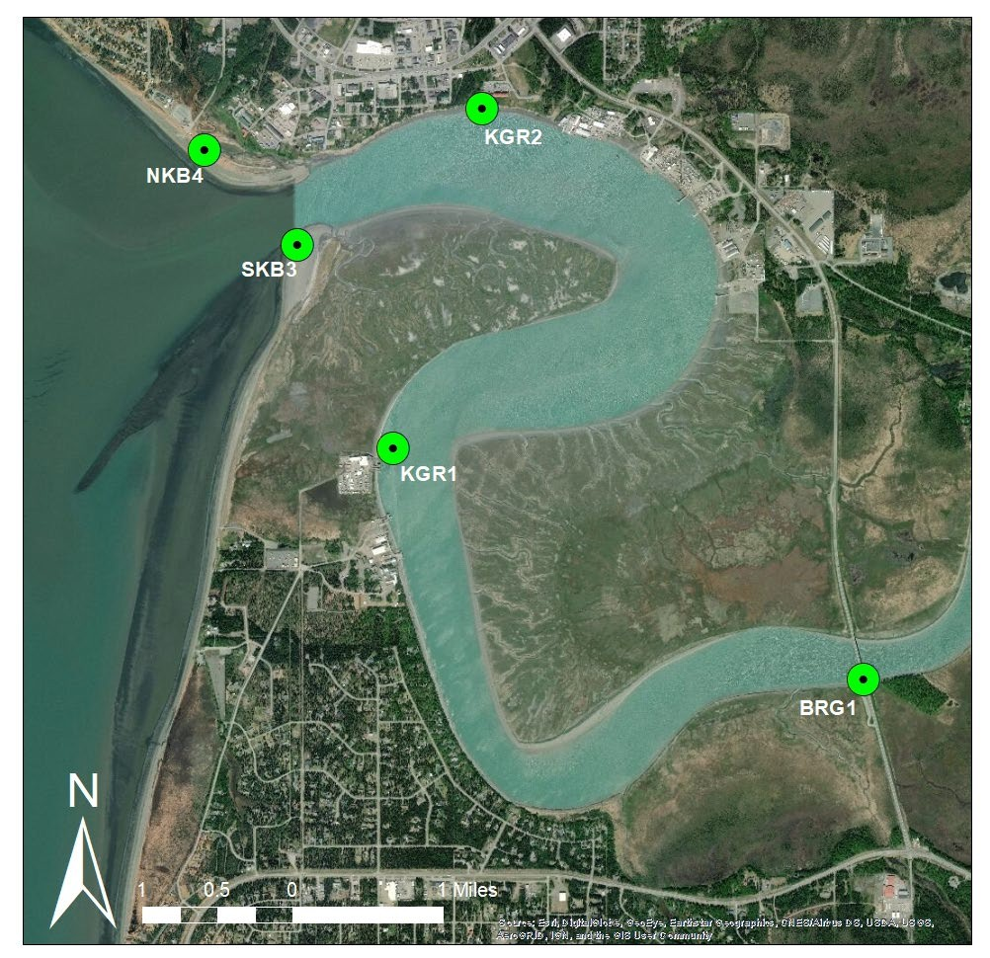

**Sampling Site Codes**: NKB4: North Kenai Beach, SKB3: South Kenai Beach, KGR1: Kenai Gull Rookery 1, KGR2: Kenai Gull Rookery 2, BRG1: Warren Ames Memorial Bridge.

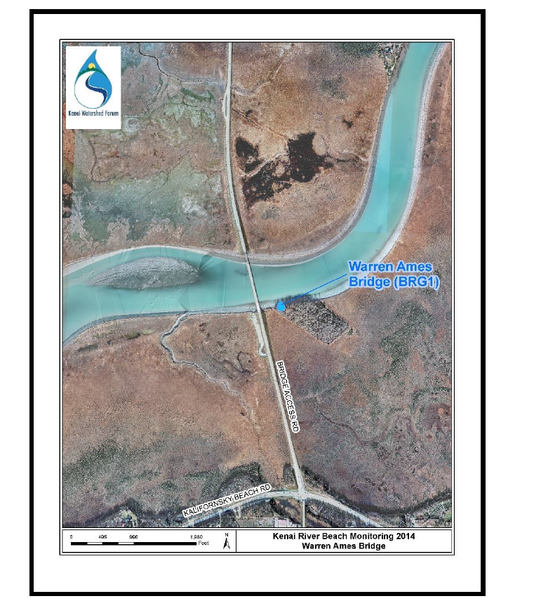

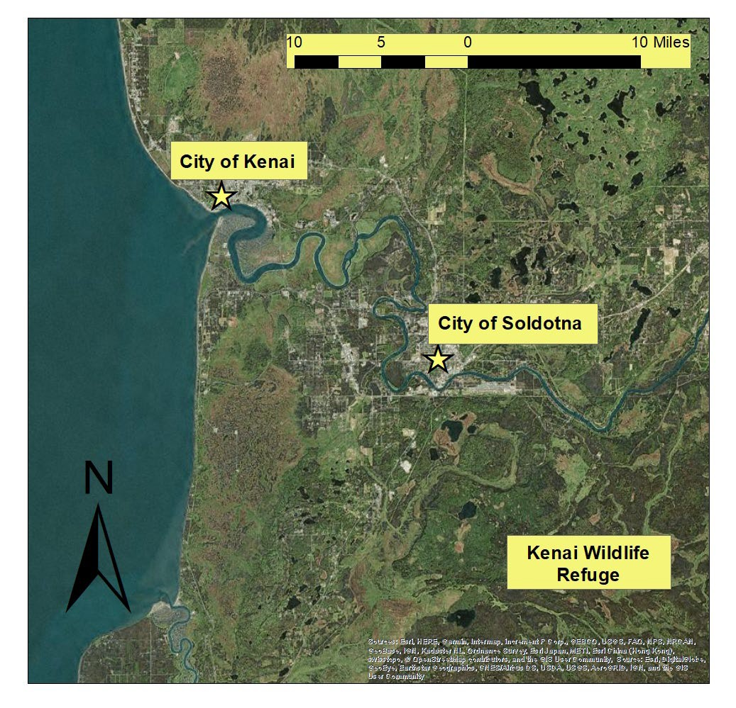

**Appendix D: Laboratory Chain of Custody Form**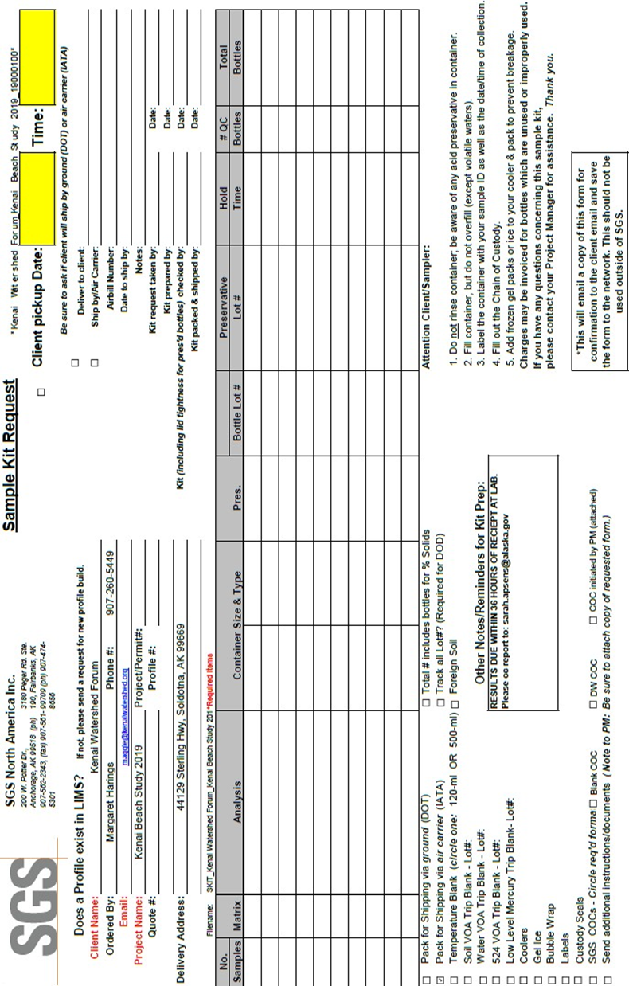

**Appendix E Kenai River Beach Monitoring Communication Plan**

**FY20-FY21**

**Background**

In response to increased occurrences of water-borne illnesses U.S. Congress passed the Beaches Environmental Assessment and Coastal Health (BEACH) Act in 2002. EPA administers grant funds to states, tribes and territories under the Act to establish monitoring and public notification programs. The Alaska Beach program has established national marine water quality monitoring and reporting standards for fecal waste contamination and notifies the public when levels exceed state standards.

The Alaska DEC’s Division of Water uses EPA grant funds for the Alaska Beach program. This program provides funds to local government, watershed organizations, and tribal groups to conduct water quality monitoring on high-priority public beaches. Beach programs have been implemented in 15 Alaskan communities.

**Campaign Goal**

*Evaluate potential health risks indicated by fecal coliform and enterococci bacteria at specific recreational marine public beaches, and notify the public when levels exceeded state standards. Ultimate WQSAR goal is to improve water quality and reduce nonpoint source hazardous bacterial pollution to beaches, and the environment.*

**Key messages**

* Increase recreational beach user awareness of potential bacteria sources, the best management practices (BMPs) to improve water quality and beach health (FAQs on BEACH webpage)[1], and to reduce health risks using available resources.
* Increase local government and tribal group awareness of BMPs to reduce bacteria in watershed and marine environments.

**Kenai Beach**

**Stakeholders**

* Recreational beach users
* Personal use fishermen and fisherwomen
* Beach landowners
* City of Kenai, Kenai Peninsula Borough
* Local tribal groups
* Other state and federal agencies

**Communication Activities**

Outreach events including, but not limited to: Kenai River Fest, Stream Watch Kenai Beach Booth. Inform the public about the Alaska Beach Program and recreational water quality monitoring. How it can benefit beach users and how beach users can keep themselves and their favorite beaches health.

**Communication Tools**

* Press releases on recreational advisories and/or weekly list serve updates – DEC Kenai lead to prepare and send throughout the recreational season presenting updated results and current status of beaches
* Social media weekly post – DEC Kenai lead to prepare/post updated advisories, DEC PIO to advise
* Website Updates – DEC Kenai lead will update Kenai Alaska Beach website to include press releases, weekly bacteria results, update the interactive mapper, monitoring report , and additional resources on pollution prevention
* Community Events – DEC Kenai lead to attend community events to inform recreational users about the Kenai Beach Monitoring program, potential bacteria sources, and best management practices
* Brochures, Rack Cards, and Flyers – DEC Kenai lead and/or grantee to develop and provide informational materials to the community. Materials will include QR codes website information to direct public to visit the Beach Monitoring Webpage
* Radio Announcements – DEC to prepare a five second script for local (and Anchorage/Wasilla) radio host to announce. Scrip should will direct public to visit the DEC Beach Monitoring webpage for information on Kenai beaches. DEC to prepare a longer script (15-30 seconds) and have professional voice record (budge dependent)
* Post Recreational Advisories – DEC to coordinate with beach property owner
* Technical Assistance – DEC appropriate section lead to meet with local governments, tribal groups, and other agencies (e.g., Fish and Game).

**Resources**

* DEC Webmaster
* DEC PIO – Laura Achee
* Kenai Watershed Forum – Contractor to grantee

**Personnel**

* Primary DEC Beach Program and Ketchikan Beach Lead: Gretchen Augat
* DEC Kenai Beach Lead: Sarah Apsens
* Other DEC staff may assist at community events/sampling events as needed or available
* Other agency staff: Kenai Watershed Forum, Stream Watch, ADFG, FWS staff may coordinate on efforts to communicate with the public and landowners

**Who to notify and what actions to take when bacteria exceeds water quality standards**

**Pre-Monitoring/Recreation Season**

Issue a general press release outlining the 2020 program, how the community will be informed of monitoring results, and precautionary measures for recreational users if bacteria levels exceed contact recreation criteria.

**In-Monitoring/Recreation Season**

**Sample Results Available** – Lab notifies the following contacts of that week’s monitoring results:

1. DEC Project Manager – Sarah Apsens
2. City of Kenai Project Manager – Bob Frates
3. City of Kenai Manager – Paul Ostrander
4. Kenai Watershed Forum, Project Contractor – Margaret Harrings, Branden Bornemann

**Sample Results Exceed Contact Recreation Criteria of 130 CFU / 100 ml enterococci**

Enterococci < 130 CFU/100 ml

Enterococci > 130 CFU/100 ml

DEC Project Manager will:

1. Update listserv reaching interested stakeholders[2]
2. Update interactive map and results table on DEC Beach Webpage:
3. Update DEC Facebook post, submit to DEC PIO – Laura Achee
4. Contact landowner about possibility of beach signage if bacteria levels exceed contract recreation criteria ( > 130 CFU/100ml)

1,000 CFU/100ml ≤ Entero ≤ 10,000 CFU/100ml

**Sample Results Exceed 1,000 – 10,000 CFU / 100 ml enterococci**

In addition to above actions, DEC Project Manager will:

1. HSS State Epidemiologist – ask for reports of illnesses due to beach water exposure
2. Implement additional actions based on consultation with State Epidemiologist and landowners (City of Kenai)
3. Advise DEC DOW Director and Commissioner of exceedance level

Entero ≥ 10,000 CFU/100ml

**Sample Results Exceed 10,000 CFU / 100 ml enterococci**

Additional Notifications

1. Directors of DFG (Sport Fish), DNR (Division of Parks & Recreation, Division of Mining, Land & Water), DEC Environmental Health Lab
2. HSS State Epidemiologist – ask for reports of illnesses
3. Discuss possibility of restrictions on use, or temporary beach closures with landowner

Table 1. Contact Information for Beach Bacteria Monitoring

|  |  |  |  |  |
| --- | --- | --- | --- | --- |
| **Name** | **Organization** | **Position/Title** | **Phone #** | **Email** |
| Sarah Apsens | DEC, Water | Project Manager | (907)262-3411 | sarah.apsens@alaska.gov |
| Gretchen Augat | DEC, Water | Alt. Project Manager | (907)465-5023 | gretchen.augat@alaska.gov |
| Chandra McGee | DEC, Water | Alt. Program Manager | (907)451-2140 | chandra.mcgee@alaska.gov |
| Paul Ostrander | City of Kenai | City Manager | (907)283-8223 | postrander@kenai.city |
| Margaret Harings | Kenai Watershed Forum | Beach Monitor | (907)206-5449 | maggie@kenaiwatershed.org |
| Branden Bornemann | Kenai Watershed Forum | KWF Director | (907)206-5449 | branden@kenaiwatershed.org |
| Colton Lipka | ADF&G | Area Sport Fish Biologist | (907)262-9368 | Colton.lipka@alaska.gov |
| Jenny Gates | ADF&G | Kenai Assistant Biologist | (907)262-9368 | Jenny.gates@alaska.gov |
| Jack Blackwell | ADNR | Park Superintendent Kenai/Prince William Sound Region | (907)262-581 | jack.blackwell@alaska.gov |
| Dr. Joe McLaughlin | HSS Public Health Nurses | Epidemiologist | (907)269-8000 | [eph@alaska.gov](mailto:eph@alaska.gov) |
| Jerry Trohynski | HSS Public Health Nurses | South Central  Regional Nurse Manager | (907)334-2251 | [jerry.troshynski@alaska.gov](mailto:jerry.troshynski@alaska.gov) |
| Kimberly  Stryker | DEC, Food  Safety | Program  Manager | (907)269-7501 | kimberly.stryker@alaska.gov |
| Dave Rutz | ADF&G,  Sport Fish | Director | (907)267-2150 | david.rutz@alaska.gov |
| Ricky Gease | ADNR, State  Parks | Director | (907)269-8700 | [ricky.gease@alaska.gov](mailto:ricky.gease@alaska.gov) |
| Martin Parsons | ADNR  Mining, Land, Water | Director | (907)269-8625 | [marty.parsons@alaska.gov](mailto:marty.parsons@alaska.gov) |
| Randy Bates | DEC | Director, Division of Water | (907) 269-7673 | randy.bates@alaska.gov |
| Jason Brune | DEC | Commissioner | (907) 465-5066 | [dec.commissioner@alaska.gov](mailto:dec.commissioner@alaska.gov) |

**Appendix F Field Data Sheet**

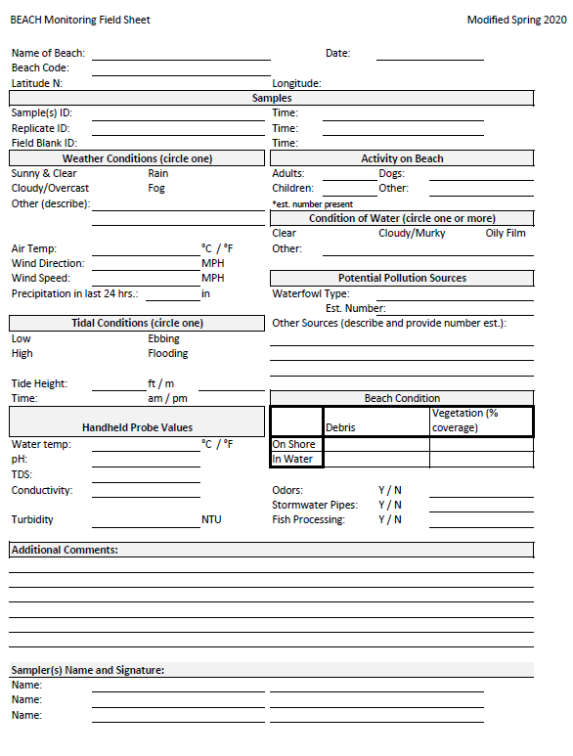

1. Maintain your septic system. Pick up your pet’s waste and dispose in appropriate location. No feeding birds or other wildlife. Use a harbor pump-out station instead of releasing holding tank near recreational areas. Dispose your fish waste appropriately. Encourage others to do the same.
2. Stakeholder List includes - e.g., federal/state/local/tribal governments (DNR, HSS, City/Borough Public Works, Vice-Mayor, City Manager, Harbormaster, legislators) and interested community members